Case Study Explanation (with SQL Queries)

Jerry Yang

Contents

Questions from the Case Study 3

Associate & Portfolio 3

Responsiveness 3

Client Communications 3

Escalation & Churn 3

Client Health Score 3

Work in Progress 3

Answers and SQL Queries 4

Creating the Separate Tables 4

Changing the Date and Finding the Tenure 4

Ramping and On Hold 5

Transforming the Table with Joins 6

Responsiveness and Client Communications 7

Escalation, Churn, Client Health, and WIP 8

# Questions from the Case Study

## Associate & Portfolio

1. Report the current team lead that the associate reports to.
2. Report the current operations manager that the associate reports to.
3. Report the associate's current tenure at Bench (number of days).
4. Create a field which displays the associate's current job title.
5. Create a boolean field which represents if the associate is currently ramping.
6. Create a boolean field which displays if the associate is currently on hold from receiving new clients.
7. Display the current number of clients in the associate's portfolio.
8. Report the current maximum complexity points for the associate using data from the aa_capacity_objects table.

## Responsiveness

1. Responsiveness calculation: What percentage of incoming client communications are responded to within 24 hours?
2. Use the client_responsiveness_30d table as a data source

## Client Communications

1. Use the data in the communications_summary_14d table to calculate the number of clients that the associate has messaged within the previous 14 days.
   1. Clients with an merstatus_at_reportdate of "COMPLETE" should be included in the total of clients messaged within the previous 14 days.
   2. Clients with an inboxstate_at_reportdate of "CATCH_UP" should be excluded from these calculations.
2. Calculate the percentage of clients messaged by the associate within the previous 14 days

## Escalation & Churn

1. How many escalations were raised for the associate over the previous 90 days?
2. Count the number of churns attributed to an associate within the previous 90 days.

## Client Health Score

1. Client Health Score (Exclude clients with a CATCH_UP inbox state from the following calculations:
   1. What is the average client health score per associate?
   2. How many clients have a health score of zero?

## Work in Progress

1. Report the number of available vs blocked WIP tasks per associate (See the incomplete_work_tasks table)
2. Only clients with an inbox state of KEEP_UP or CHURN should be included
3. Report the average number of available WIP tasks per client in the associate's portfolio.

# Answers and SQL Queries

I wrote all the SQL queries here using SQLite.

## Creating the Separate Tables

The main table with employees (operations_team_history) does not organize workers by team lead and associate. Therefore, I created two separate tables (associates and teamleads) based on the job title field.

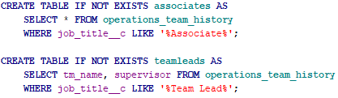

Due to the structure of this hypothetical organization, the supervisor of the associate will be the team lead, and the supervisor of the team lead will be the operations manager. Simply running a SELECT on these tables will display these answers.

## Changing the Date and Finding the Tenure

The case study specifies to assume the end date as April 13 2022. In the database, indefinite end dates are given as 2099-12-31, which had to be changed.



By updating all of these fields, the new two tables will clearly show:

* The current team lead that the associate reports to
* The current operations manager that the associate reports to
* The associate's current tenure at Bench (number of days)
* A field which displays the associate's current job title

## Ramping and On Hold

The database contains start and end dates for ramping. Because we assume that the current date is “2022-04-13,” any end date after this will be considered “currently ramping.” See the following SQL queries with comments:

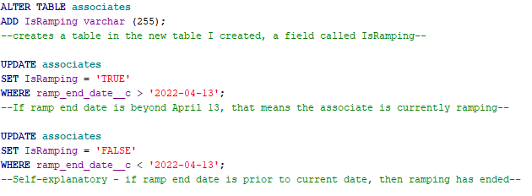

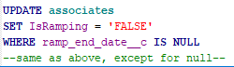

This will create and populate the “IsRamping” field with the appropriate Boolean (TRUE or FALSE) value.

We can figure out associates who are currently on hold by looking at the value within the “request_type” field.

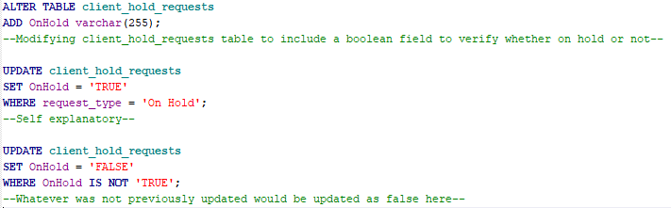

## Transforming the Table with Joins



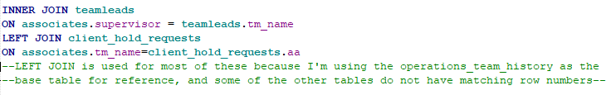

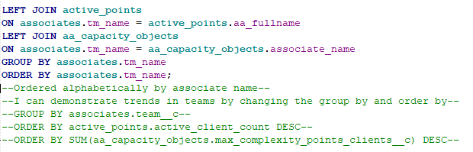

The base table used is “operations_team_history” and these tables were joined and the appropriate fields were selected. Here is a sample of the SQL Query (without any sorting):

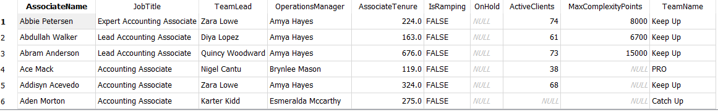

Running this clearly shows the amount of active clients and the maximum complexity points as well.

## Responsiveness and Client Communications

Responsiveness calculation shown aggregated:





March 30 is 14 days before April 13, which would

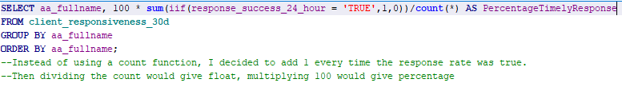

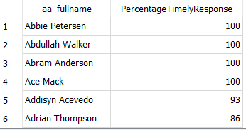

There were difficulties in this version of SQLite in creating a percentage value based on aggregate responses. As explained in the comment, a count was applied for every sequence of responsiveness given in the “client_responsiveness_30d” table.

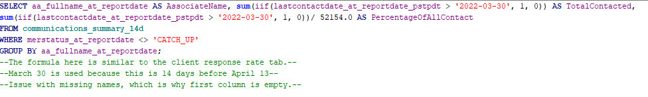

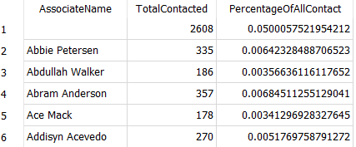

## Escalation, Churn, Client Health, and WIP

The following SQL queries are self explanatory or contain comments and give the appropriate answers to the remaining questions posed in the case study:

